***Software Requirements Specification***



**For**

**Role Based & Time Bound Access Control**

**Submitted by:**

Abhishek Kumar Gupta

(Roll No.-9914103169)

Deepanshu Kathuria

(Roll No.-9914103177)

**Under the Supervision of**:

Mrs Vartika Srivastava

**Name of Evaluator:**

Mrs Arti Jain

**Department of CSE**

**Jaypee Institute of Information Technology, Noida**

# October 2016

**Acknowledgement**

I would like to place on record my deep sense of gratitude to **Mrs Vartika Srivastava**, Designation, Jaypee Institute of Information Technology, Noida for his/her generous guidance, help and useful suggestions.

I express my sincere gratitude to **Mrs. Vartika Srivastava**, Dept. of Computer Science & Engineering, Noida, for his/her stimulating guidance, continuous encouragement and supervision throughout the course of present work.

I also wish to extend my thanks to **Mrs. Vartika Srivastava** and other classmates for their insightful

comments and constructive suggestions to improve the quality of this project work.

**Signature(s) of Students**

Abhishek Kumar Gupta (9914103169)

Deepanshu Kathuria (9914103177)

## Contents

.

**1.Introduction** .......................................................................................3

* 1. Document Purpose ......................................................................3
  2. Product Scope............................................................................. 3
  3. Intended Audience and Document Overview............................. 3
  4. Definitions, Acronyms and Abbreviation................................... 3
  5. IEEE References…………………………………………..........3

1. **Overall Description**............................................................................4
   1. Product Perspective .....................................................................4
   2. Product Functionality ..................................................................4
   3. Users and Characteristics ............................................................4
   4. Operating Environment ...............................................................4
   5. Design and Implementation Constraints......................................5
   6. Assumptions and Dependencies ..................................................5
2. **Specific Requirements** ..................................................................6
   1. External Interface Requirements ................................................6

3.2 User Interfaces.............................................................................6

3.1.2 Hardware Interfaces ....................................................................6

* + 1. Communications Interfaces .........................................................6

3.1.4 Software Interfaces ......................................................................6

* 1. Functional Requirements…………………………………..........7

3.3 Behavioural Requirements ..........................................................7

* + 1. Use Case Diagra...........................................................................7
    2. Class Diagram..............................................................................7

1. **Non-Functional Requirements** ................................................8
   1. Performance Requirements...........................................................8
   2. Safety and Security Requirements ...............................................8
   3. Software Quality Requirements....................................................8

**5. Database Requirements** ..............................................................9

## 1. Introduction

### 1.1 Document Purpose

The purpose of this document is to describe in details the requirements of Role Based and Time Bound access by which user can track past and current information about his/her health or the health of someone in his/her care. Sometimes this information can save the money and inconvenience of repeating routine medical tests. Within this document, readers can find information about our general project concepts, a list of functional and non-functional requirements.

### 1.2 Product Scope

The system will be partitioned as 2 definitive modules: 1. User Module- In this module user will be able to directly access the website content using any browser. 2. Administrator Module- the administrator can control the behaviour of the website and can add or remove the content of the website.

### 1.3 Intended Audience and Document Overview

The Intended Audience of the project ‘Role Based and Time Bound Access Control(RBTBAC)’ are the doctor who need to treat patients and patient who need to view his medical record. This document also describes the design constraints and other factors necessary to provide a complete and comprehensive description of the requirements for RBTBAC.

### 1.4 Definitions, Acronyms and Abbreviations

* SRS – Software Requirement Specification.
* Front End – This stands for the interface that the user will see while using the application.
* Client – This stands for all the end users using the application.
* Administrator – An individual responsible for managing user accounts, contents, and security of a website, database, or other system.
* Notes – Text added to content and stored in the database; may be private (viewable only by administrators or moderators), or public (viewable by any user).
* CLI: Command Line Interface
* API: Application Programming Interface
* ROM: Read-Only Memory
* HTML: Hypertext Mark-up Language
* CSS: Cascading Style Sheets
* PHP: Personal Home Page
* BOOTSTRAP: Tool for designing front end.
* RBTBAC: Role Based and Time Access Control

**1.5 IEEE References**

1.Published by Rui-Zhuang ,6 June 2014: Role Based and Time Bound Access and Management of EHR data.

2.Published in SEA ’07 Proceedings of the 11th IASTED International Conference on Software Engineering and applications,11 June 2007:

Role Based Implementation.

**Summary**:

* Role-based access control (RBAC) is designed to simplify security administration by introducing the ’role ‘abstraction between principles (subjects) and privileges (objects).
* Three phases of RBTBAC model:
* Role based-management
* Time bound management
* Path Invisible Access control
* Role-based Key Structure is applied here.
* Encryption and Decryption Key Structure: To encrypt and decrypt data, system uses key tree.
* Different Keys for different patient.
* To avoid inconvenience, RBTBAC uses a master key.
* For time, bound management RBTBAC model uses time tree method.
* Time Binary Tree: Binary tree index has two or less than two nodes for time.
* Time multi tree.
* Space Complexity: It has effective space complexity.

## 2. General Description

### 2.1 Product Perspective

The proposed system will be able to maintain data security of the patient's medical record. Authorized users shall be able to view, access and update the information of any patient. Any user visiting the site shall be able to use every feature mentioned providing their computer has the proper software and/or hardware, if the user is authorized. Implementation of RBTBAC model can assure the data security as a user can only view the information of certain patient for a limited period of time.

### 2.2 Product Functionality

RBTBAC model contains algorithms verified and proved by expert which is used for authentication. Only authorized user can access the personal data or the data. The user will be allowed to access the data of the patient for a certain period of time.

### 2.3 User Characteristics

The majority of users will be the doctors. Users can be classified as follows: -

**Administrator**: The master controller of the system (Can be more than 1).

**Doctor**: The end users with requisite privileges to use the system.

**Patient**: They will be the one who are most benefited with this project.

### 2.4 Operating Environment

The webpage is compatible with all the web browser of a computer. The operating environment of the project is as follows:

1. Front end: HTML, CSS, JavaScript, Bootstrap

1. Operating System: Windows 7

1. Back end: PHP, PostgreSQL Database

1. Hard disks: 60GB

1. RAM: 512MB

### 2.5 Design and Implementation Constraint

Each user must keep their password as confidential. More over the user must have individual ID for creating a login in the system. Only Administrator can control user addition and deletion in the system.

Design constraints are as follows: -

* Understandability of the webpage differs from user to user. We have presented to the user with simple, recognizable and intuitive screen.
* Speed: We have worked diligently to make the delay in presenting the data to be zero. Any occurrence of irrelevant data is prevented.

### 2.6 Assumption and Dependencies

* The program will run for Medical purposes.
* Users should know how to use a smart phone and a computer.
* Users should know how to use a web browser
* Each user must have a UserId and password
* Internet connection is must
* Proper Software should be installed

## 3. Specific Requirements

### 3.1 External Interface Requirements

#### 3.1.1 User Interfaces

Once the program has been launched, the user will interact primarily with the webpage. Since the program will be designed with simpler mechanics and ease of use in mind, the GUI is not overly complex. Whatever interface is used is in fact kept readable and minimalist in order to accommodate all the type of screens.

#### 3.1.2 Hardware Interfaces

The users need to have access to a keyboard, monitor, and a computer to view and manage our webpage and take the advantages of RBTBAC model. Users are highly recommended to have a mouse and keyboard for full functionality.

#### 3.1.3 Software Interfaces

The users need to have a functional operating system that includes an up to date Internet browser with JavaScript enabled, such as Internet Explorer, Google Chrome, Firefox, Opera or Safari.

**3.1.4 Communication Interfaces**

The users need to have access to unrestricted Internet via broadband, dial-up or wired.

### 3.2 Functional Requirements

1. **System shall allow the administrator login**

A possible threat exists if the system does not recognize a proper administrator login. To prevent this risk extensive testing with multiple user logins should find any problems.

1. **System shall allow the administrator log out**

A possible threat exists if the system does not recognize a proper log out and keeps the administrator logged in, possibly giving someone unauthorized access. To prevent this risk extensive testing shall be done to insure there are no problems.

1. **System shall allow the administrator to provide authorization**

1. **Description: -**

After a successful login, an administrator shall be able to manage accounts.

2. **Technical issues: -**

Login error.

3. **Grant privileges: -**

Administrator can grant different privileges to users.

4. **Revoke privileges: -**

Administrator can revoke different privileges from users.

4. **Authorized user can view the details of patient.**

5**. Key generation: -**

Key should be generated from server side.

6.**Implementation of RBTBAC model:**

Role Based Access: Only authorized can access the information of any patient.

Time Bound Access Control: User can view the data for a limited period of time.

### 3.3 Behavioural Requirements: -

**3.3.1 Use Case Diagram**

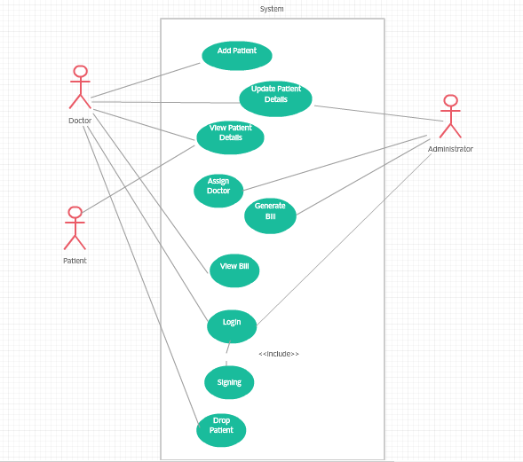

**3.1.2 Schema Diagram**

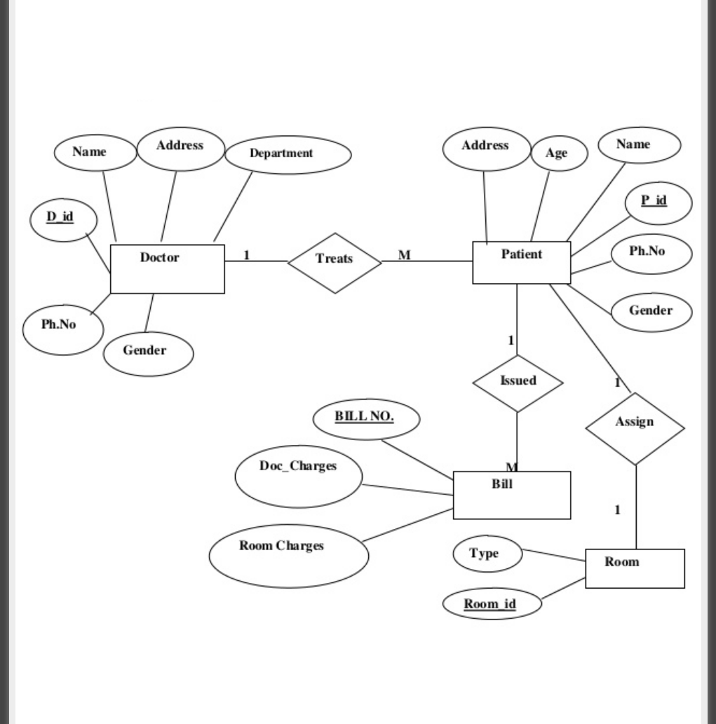

## 4. Non-functional Requirements

### 4.1 Performance Requirements

The system should be accessible 24 hours a day, 7 days a week as long as the server is up and running correctly.

The users of the system shall be able to view data from their chosen web browser consistently and from any computer they want to.

The system should be well documented and provide simple navigation, so future individuals can keep the site up-to-date.

Users data should be secured.

### 4.2 Safety and Security requirements

The secure system shall be able to verify the administrator’s username and password. In order to maintain correct information data should be accessed by authorized users. There should be the proper key system.

**4.3 Software Quality Attributes**

### Maintainability

The system should be easily maintainable for the average administrator and user. Through the use of the secure log-in, authorized users should be able to add, edit, or delete any personal or medical information that they feel necessary. In order to do so, the system should be well secure, so the administrator can keep the site up-to-date.

**Portability**

The system should allow authorized users to access its secure information, from any web browser, as well as through a mobile device.

### Reusability

The system should implement a Role Based and Time Bound Access with a secure login feature for the administrator to access the site in order to maintain and update the information as needed, as well as organized documentation about system. The documentation will allow the users to learn how to add, delete, edit files and update information easily through the use of Role Base and Time Bound Access Control Model.

### Application Affinity/Compatibility

The system should be compatible with an internet connection of at least 56K and modern web browser such as Firefox, Internet Explorer, Safari and Google Chrome, regardless of the Operating System that users in using.

### Resource Utilization

The system shall require input from a mouse and keyboard, an output from a monitor and steady Internet connection to fulfil its client’s desired requirements.

### Serviceability

Any future modifications or services that Role Based and Time Bound Access requires, shall to be easily implemented and managed for the average administrator with this system due to the well-designed layout of the site and its corresponding documentation.

## Database Requirements

* **Language**- SQL
* **Software**- PostgreSQL, XAMP
* **Space Required**-20GB

**Conclusion**

The main objective of our project ‘Role Based & Time Bound Access Control’ is making a website for database security purpose. This access control model emphasizes more on flexibility of roles and has the capacity to control the access of sensitive data from time dimension. For role based, we have developed a privacy-aware method. For time bound, we have employed a time tree method for generating time granule values. RBTBAC model is more suitable since it offers high efficiency and better security and privacy for patients.

We can consider much future scope to this website. The following are:

* We are interested in to keep the record of real medical data which are hard to get.
* RBTBAC model can be applied to many different fields, especially sensitive information system such as government or military systems, banking systems and e-commerce systems.
* The RBTBAC model can be used in the systems storing a mass of data on untrusted remote DB or cloud.
* It can be used to guarantee better security and privacy of data sharing.